Sheet Manager Tools

*(Updated 2015-11-16 by Jinsol Kim)*

## **Overview**

The Sheet Manager Tools consists of two separate components, Sheet Data Editor and Sheet Data Manager, which read and write the same structure of database schema to communicate between those two components with database files.

**The Sheet Data Editor** is a stand-alone tool that has built as a ClickOnce application which can be installed and run on users’ desktop. The Editor will provide features to create SQLite database files and manipulate contents of the data within individual windows for each corresponding tables *(See more details in* *1. Sheet Data Editor**)*.

On the other hands, **The Sheet Data Manager** is a Revit add-in tool that reads data from the database file generated by the Editor and create new elements or update existing elements of Sheets, Revisions, and Views in Revit *(See more details in* *2. Sheet Data Manager (Add-In)**)*.

If a certain database is connected with the updater feature on, the add-in will register updaters that monitors all sheets and revisions elements and their parameters, so that if any of changes on those two categories of elements are detected, the modification will be applied to the connected database *(See details in* *3. Data Updates* *)*

Contents

**Overview** 1

1. Sheet Data Editor 3

1.1 Database Tables 4

1.2 Create Database 4

1.3 Sheets and Disciplines Items 5

1.4 Revisions and Matrix Items 7

1.5 View Items 8

1.6 Replacement Items 8

2. Sheet Data Manager (Add-In) 10

2.1 Revit Model Requirements 10

2.2 Connect To a Database 12

2.3 Creating or Updating Sheets 13

2.4 Managing Revisions 14

2.5 Placing Views on Sheets 16

2.6 Replacing Parameter Values 17

3. Data Updates 19

3.1 Connection to Multiple Models 19

3.2 Reloading Data in Sheet Data Editor 20

# 1. Sheet Data Editor

In the Sheet Data Editor, users can create a new database file to be connected to the sheet Data Manager for the future use, and modify the contents of each individual items by creating relationships between items.

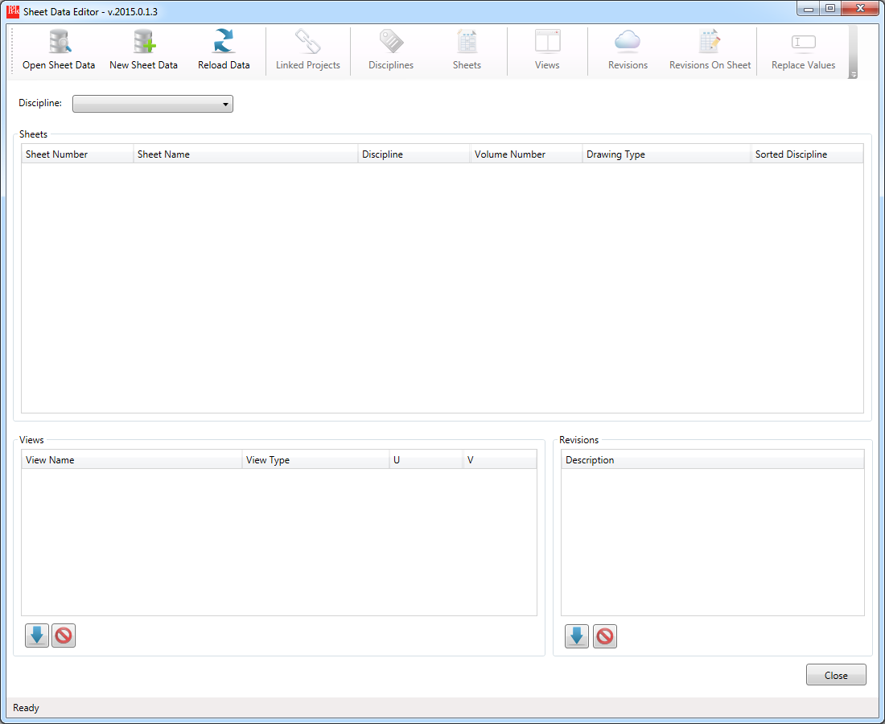

## 1.1 Database Tables

The database schema defines 11 tables related to sheets, revisions, views and links to Revit elements.



## 1.2 Create Database

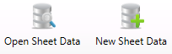

You can either open an existing template database file or create a new file to start entering sheet items on the file. By Clicking New Sheet Data button, it will create the entire set of data tables in the file and connect to each components in the Editor.

## 1.3 Sheets and Disciplines Items

**Discipline Items**



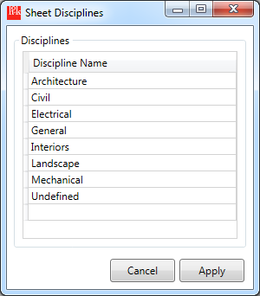

- To add a discipline, enter a name in the last row and hit Enter key.

- To delete a discipline item, select the item and hit Delete key.

**Sheet Items**





* To add a sheet item, enter sheet information and select a discipline from the drop-down menu at the last row and hit Enter to move next row.

** Sheet Number and Sheet Name fields are required and colored with red fill.

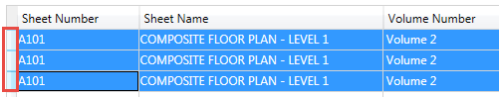

* To delete sheet items, select row headers (marked as a red rectangle above) and enter Delete key.

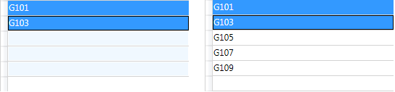

* To Auto-Fill like Excel spreadsheet, **right click** on a cell to be copied and drag and drop to a cell to fill auto-incremented values.

If the initial cells contain numeric suffixes, the difference will be calculated from two first rows and will keep adding the amount for the rest of the rows. Default step is 1.

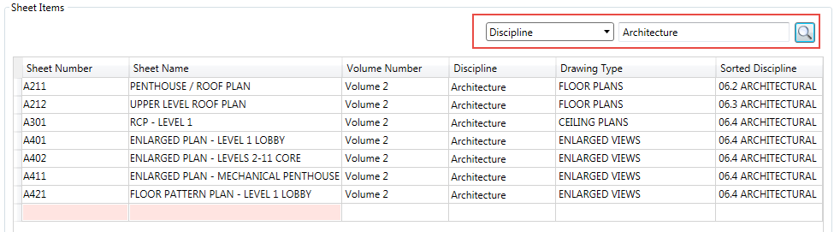

* To search items, select a column name from the drop down menu, and enter a search text and hit Enter or the search button. If empty string is entered, it will display the default view.
* Click the **Apply** button to save changes in the database.

## 1.4 Revisions and Matrix Items



**Revision Items**

- To add a revision item, enter revision information at the last row and hit enter.



You can select a linked document to a revision item by clicking the […] button in the cell.

- To copy revision item, right click on the source cell and drag drop to the destination cell.

- To delete items, select row headers or individual cells and enter Delete key.

- Click the Apply button to save revision items in the database.



**Revisions on Sheet Matrix**

After creating sheet and revision items, you can define matrix between those two categories.

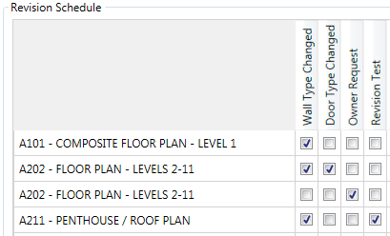

-Select revisions to be included on sheets and click the Apply button.

## 1.5 View Items



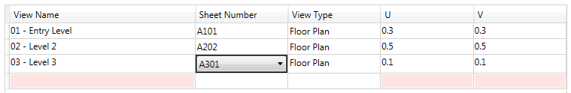

- To add view items, enter view information at the last row and assign a sheet number from the drop-down menu.

** View Name and UV location will be required for the view to be placed on the assigned sheet.

- To delete items, select row headers or cells and enter the Delete key.

- Click the **Apply** button to save the items in the database.

## 1.6 Replacement Items



**Sheet Number**

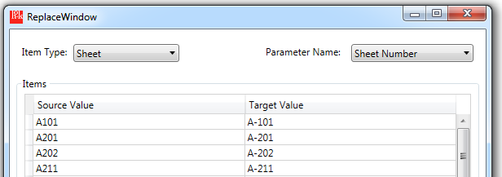

- To renumber sheets, select Sheet in the item type menu, and Sheet Number for the parameter name.

If sheets of which names are matched to the source value exist in the Revit, they can be replaced with the assigned target values.

**View Name**

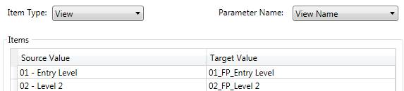

- To rename views, select View as an item type and View Name as a parameter name.

If names of views defined in the source value are found in Revit project, they can be overwritten with the target values.

# 2. Sheet Data Manager (Add-In)

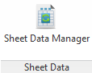

Once the sheet data has been prepared by the Editor, users can connect the database to a certain Revit project to manage sheet and revision elements by synchronizing data between Revit elements and the connected database. When initializing the Sheet Data Manager, all existing sheet and revision elements not recognized by the database will be written in the database with the link information.

## 2.1 Revit Model Requirements

**Project Information and Worksharing**

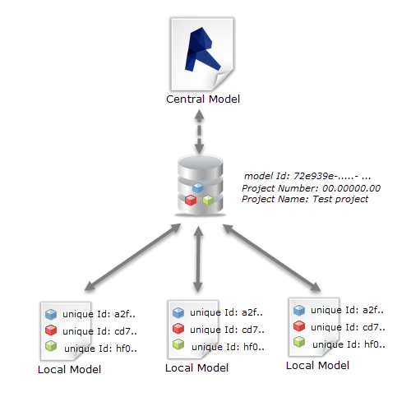

If it’s the first time to open the database in a certain Revit project, the Sheet Data Manager will record the project information and the central model path by creating a single **model ID** (as GUID) per a central model and storing the model ID in [*Extensible Storage*](http://help.autodesk.com/view/RVT/2016/ENU/?guid=GUID-113B09CA-DBBB-41A7-8021-005663B267AE). When users work on their own local files, and connect to the same database file, the local models will be given the equivalent model ID as the central model in order to share the status of linked items in the work-sharing environment.

* Enter a valid project number and a project name in Project Properties.

**Shared Parameters in Sheet**

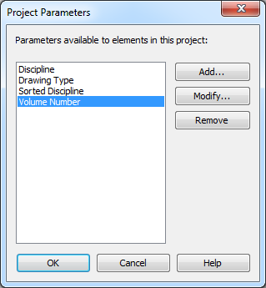

* From the HOK standard shared parameter file, add shared parameters under the HOK Title Sheets group to the Sheets category.
* Required Parameters: “**Discipline**”, “**Drawing Type**”, “**Sorted Discipline**”, “**Volume Number**”

*(Shared Parameter File: V:\RVT2016\HOK Support\HOK Shared Parameters.txt)*

## 2.2 Connect To a Database

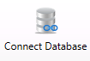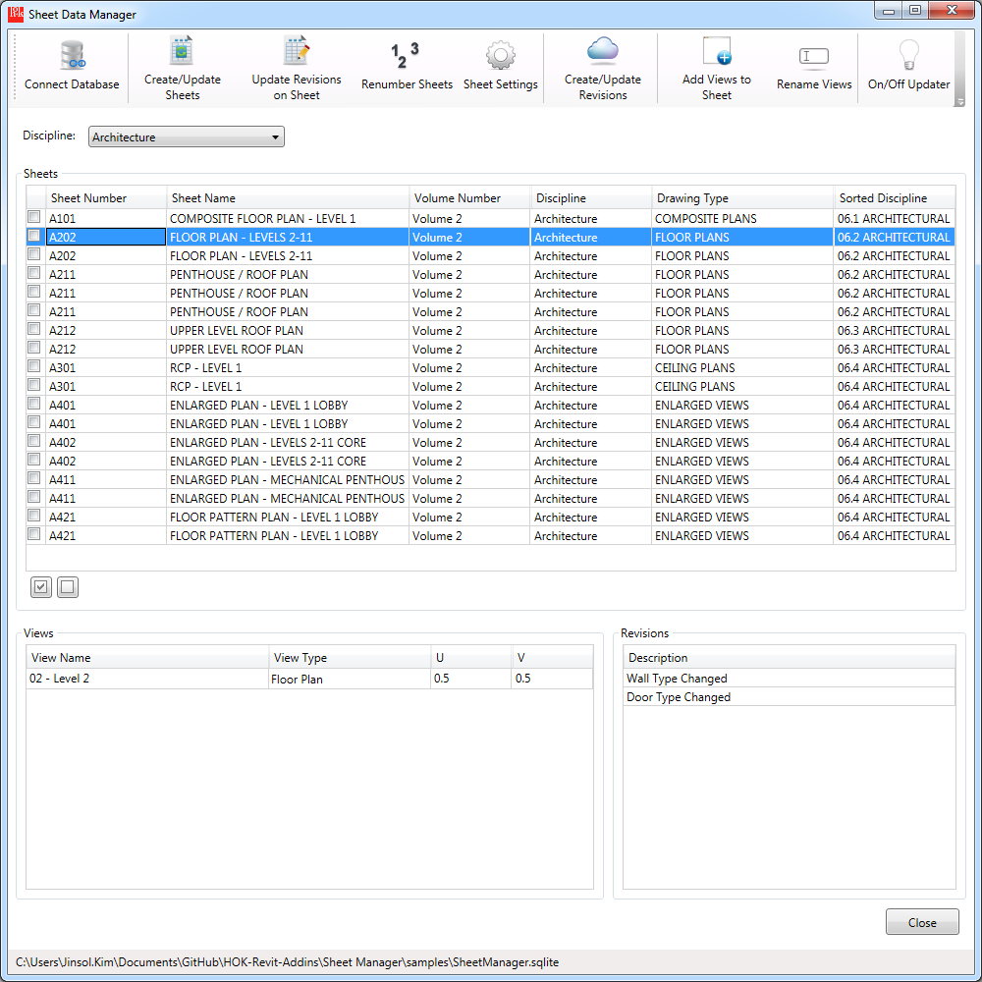

- Click the **Connect Database** button and open a database file generated by the Editor. The status label in the bottom of the window will show the currently linked database file.

## 2.3 Creating or Updating Sheets

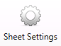

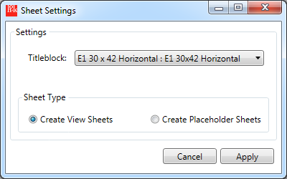

* Before creating sheets in the current Revit project, review the sheet settings to select a titleblock family and a sheet type.

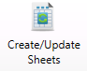

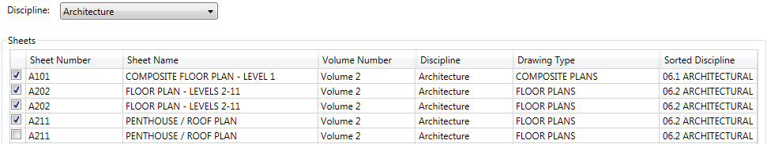

* To create sheets in Revit, select a discipline in which the sheet items belongs to, and select the check box of sheet items and click the command button Create/Update Sheets.



* After creating sheets, gray text means the item is synchronized without discrepancies between the Revit element and the data in the database. When mouse-hovering, the tooltip text will provide more detail information of the status of the link.

## 2.4 Managing Revisions

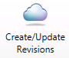

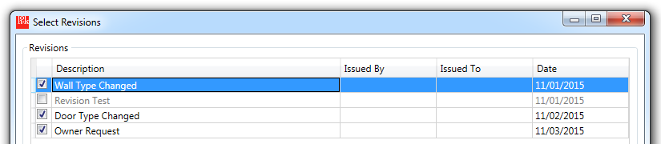

- To create or update revision items following the database, click the revision button and select revision items from the list and click the **Update** button in the bottom right corner.

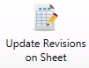

If sheet items and revision elements are linked correctly with the database (marked grey text), you can apply the revisions on sheet as defined from the Editor. In order to review the matrix, navigate to a sheet item from the main list and find revision items to be included.

Blue Text means the item has not been included to the sheet yet as the tooltip describes.

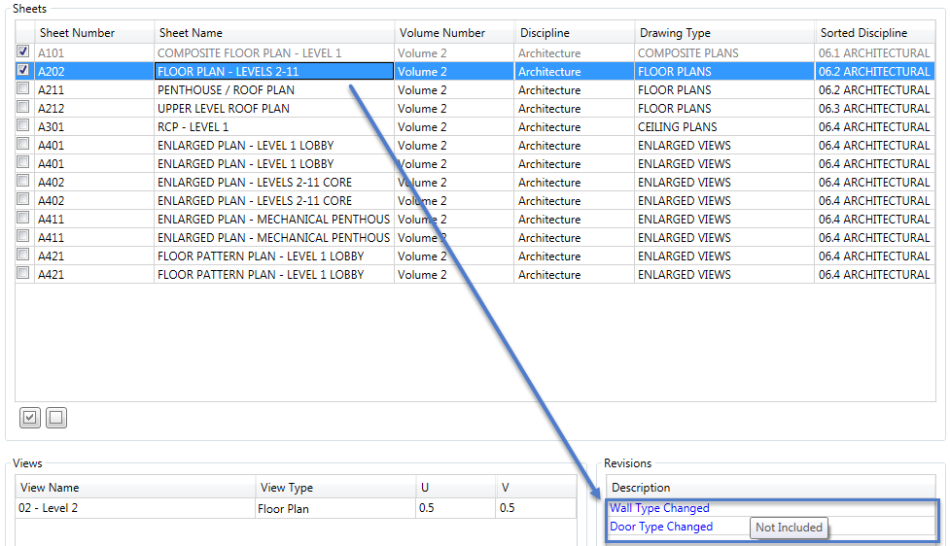

- Select the check box of sheet items and click the Update Revisions on Sheet button.

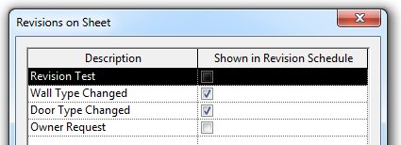

Revisions on Sheet in the properties of the sheet will be updated.

## 2.5 Placing Views on Sheets

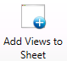

If specific views are defined onto a sheet item, the view items will be displayed in the bottom left corner by the selection of the sheet item. Since the database schema doesn’t support the link information of view items, the transient links between Revit elements and database items will be created by the names of views.

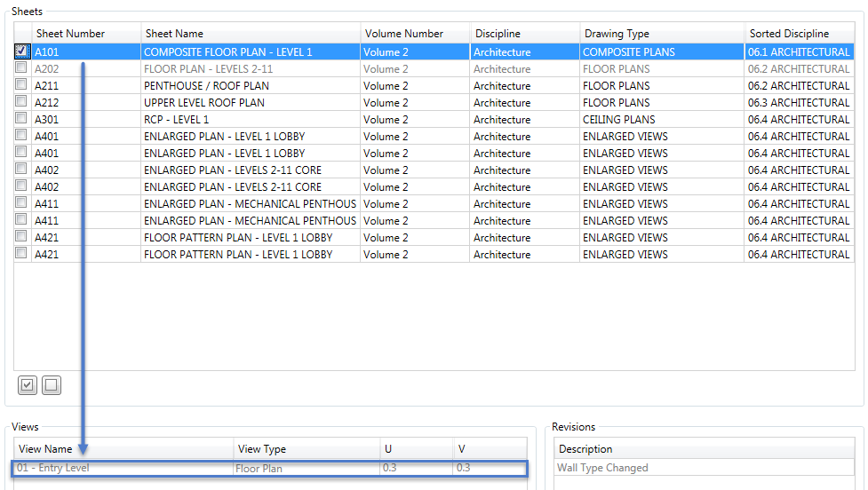

* Select sheet items that contains mapped views and click the Add Views to Sheet button. The assigned views will be placed in the sheet with the U, V offset.

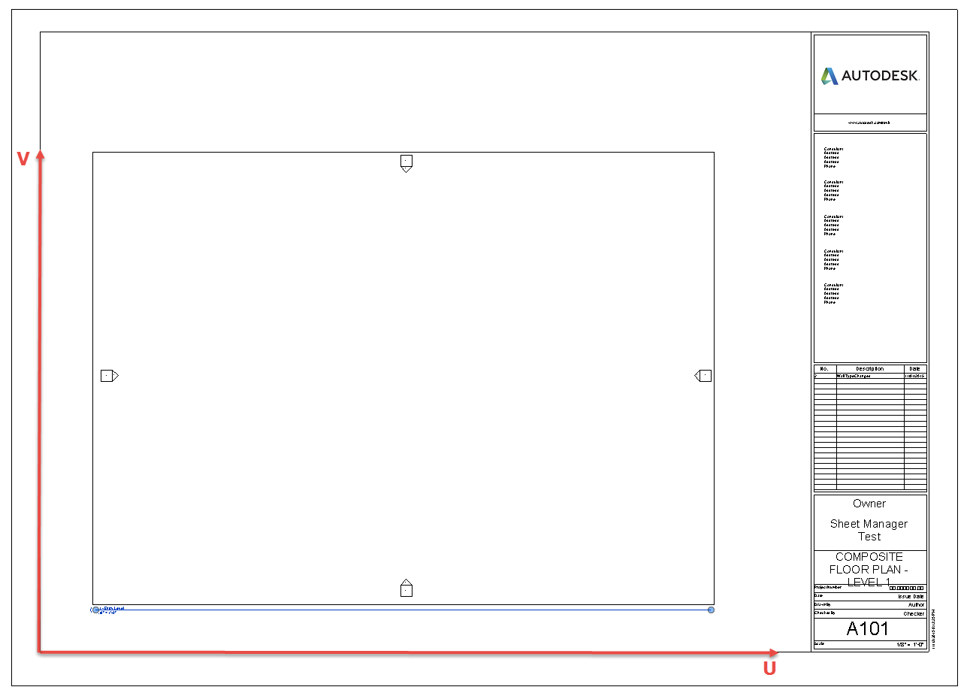

## 2.6 Replacing Parameter Values

**Renumber Sheets**

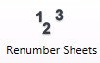

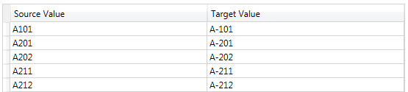

If maps for sheet numbers are created by the Editor (as in 2.6 Replacing Parameter Values), the Sheet Manager will find linked sheet items that matches to the source values and replace them with target value as new names of sheets.

Select linked sheet items from the main window, and click the Renumber Sheets button.

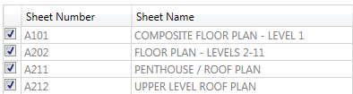

The renumbered sheet items will be written in the database and will be displayed the updated values in the main window.

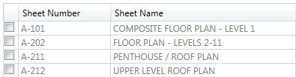

**Rename Views**



Like the process of renumbering sheets above, view names can be replaced based upon the maps created from the Editor.

If existing views match with names in the set of source values of the maps, the Sheet Data Manager will find the view and replace the name of view as the assigned target value.

# 3. Data Updates

The Sheet Data Manager contains a feature of [Dynamic Model Update](http://help.autodesk.com/view/RVT/2016/ENU/?guid=GUID-5AD1BD20-5607-4DB1-8865-BCB28A73BB42) to be able to simultaneously transfer data between the Revit elements and the database based upon the changes happening in the model. If this feature is turned on by users, the Updater will be triggered in the following circumstances.

* When creating a **sheet** element in the model,
* When changing values in one of **sheet** parameters among “**Sheet Number**”, “**Sheet Name**”, “**Discipline**”, “**Drawing Type**”, “**Sorted Discipline**”, “**Volume Number**” is changed,
* When deleting a **sheet** element if it is a source item in the database,
* When creating a **revision** element in the model,
* When changing values in one of **revision** parameters among “**Revision Sequence**”, “**Revision Number**”, “**Revision Description**”, “**Revision Date**”, “**Issued To**”, “**Issued By**”
* When deleting a revision element if it is a source item in the database,

When a database file is connected to a Revit project, the Sheet Data Manager will create a unique model ID and store the ID in the model in order to identify the project and trace the history of events of the synchronization.

## 3.1 Connection to Multiple Models

The sheet data can be transferred from one project to another by liking the same database between two different projects. If the complete sets of sheets are prepared in a source model, and if the target model requires equivalent information to create sheet elements, the database can play a role as a medium that connects between those two projects.

In order to implement, the source model should be connected to an empty database file, and the updater should be activated so that the database can be synchronized when any changes are made on sheet or revision elements in the model.

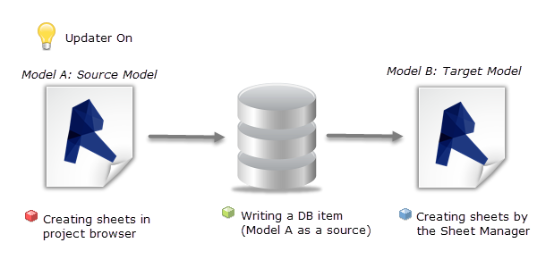

Once the list of sheet elements are ready both in the source model and the linked database, users can open a target model and populate the identical sheet elements by connecting the same database through the Sheet Data Manager.

** Items created by Model A will be marked as source items in the database, therefore, if any sheet elements in Model B originated from the database are deleted, they won’t affect to the database items.

## 3.2 Reloading Data in Sheet Data Editor



When a single database is being used by multiple clients, changes made by each client will be continuously applied to the database. In the middle of the process, the current state of data can be displayed in the Sheet Data Editor through the Reload Data button.